Company: | QUONTIC BANK | 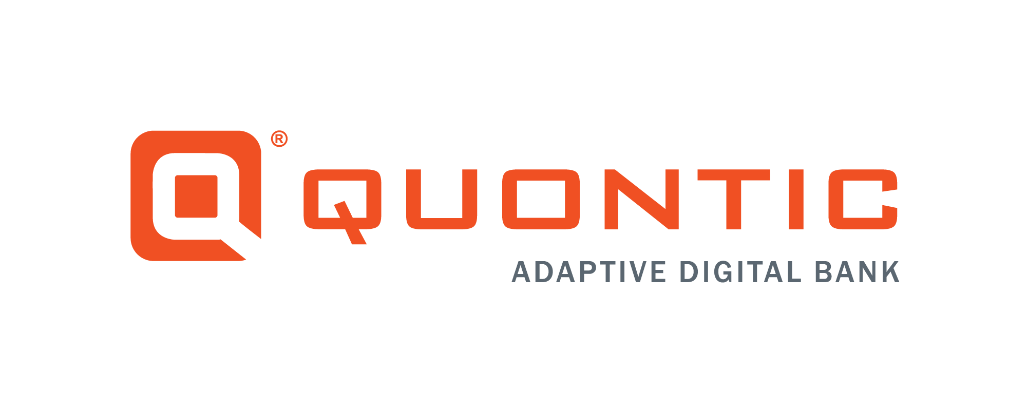
Document Title: | Account Closure
Department: | Digital Banking Operations
Date: | 7/29/2022
Author/Reviewer(s): | Cynthia Chocolatl, Ebony Grant/  Leilani Collins, Adriana Ramon
Owner: | Customer Success
Last Revision: | 10/06/2022

BACKGROUND:
Digital Banks established account closure procedures due to the client’s ability to close their account whenever they see fit. The client can contact the bank if they wish to close their account(s) through the following channels; online banking portal, email, or phone. Clients close their accounts, for example, for the following reasons: poor customer service, moving out of the country, consolidating, tech-savvy, better rates, or bank rules related.

PURPOSE:
This procedure outlines guidance for the Customer Success (CX) team to assist the client with their close-out requests received directly through the online banking portal (referred to as both OLB and Web Admin, which can be used interchangeably), email, or phone. The CX Team will use HubSpot to track and document the client’s close-out requests. The bank’s responsibility is to ensure the client’s request is completed promptly.

RESPONSIBILITY:
The CX team in contact with a client’s close-out requests is responsible for recording, acting upon, and communicating with the client once their request is completed through the CX channels (i.e., email, online banking, phone). A HubSpot ticket on the client’s contact record captures the initial contact, progress, and completion of the request.
The CX team members are responsible for the following:
- Report all close-out requests accurately using HubSpot (H.S.) tickets
- Forward the H.S. ticket to DBO-Closeout Pipeline for completion
- Prevent a complaint from the client for not completing their request or responding to their request
Digital Bank Operations (DBO) team is responsible for promptly completing close-out tickets. DBO is responsible for communicating with the CX team if further information is needed. DBO communicates with the client once the account has been closed.

CX BUSINESS RULES:
- READ ENTIRE client’s message or existing Hubspot ticket
  - Understand what the client is requesting
  - Understand what’s going on in the existing ticket
  - Reach out to your Supervisor if you need clarification
- Verify account status in Horizon XE before replying to the client’s request
- Verify how the account was opened (each type has different procedures)
  - Branch – Astoria location (permanently closed)
  - OAC (old Mantl) – certain members of the DBO have access to this application
  - MANTL
  - MANTL Max Savings
- Priorities for account closures
  - MEDIUM – waiting on the client to provide documents
  - HIGH – sending HubSpot ticket to DBO
- The client must provide an account number for receiving close-out funds
    - Quontic to Quontic Internal Transfer
    - Originating funding account – Verify this on MANTL
    - Different bank institution
- The client must provide the following information if sending the funds to a different bank institution
  - Color Copy of government-issued I.D.
  - Copy of bank statement
  - Account type
  - Account number
  - Banks routing number
- Closed interest-bearing accounts: (Money Market, High Yield Savings Account, High-Interest Checking, and Certificate of Deposit)
    - If the account is closed before interest is credited, the accrued interest may be forfeited for that accounts statement cycle
      - Interest is credited on the 10th of every month
        - If the 10th lands on the weekend, the interest will be credited the business day before
- CX must include the last four digits of the account in the HubSpot title
- CX must include how many accounts are being closed in the account title if there are more than two
- Voluntary Account Closure
  - All Voluntary account closures require the client to provide a written request with close out option
  - Inbound/Outbound Balance Account Closure Call
    - CX must send the client an email or secure message with the corresponding close-out email template
    - CX must receive a written confirmation to proceed with the close-out request
  - Account Closure Zero Balance
    - CX must send the client an email or secure message with the corresponding close-out email template
    - CX must receive a written confirmation to proceed with the close-out request
    - CX must ensure there are no pending transactions on the account
  - Account Closure less than 90 days/ more than $301+
    - CX must ask for a Color Copy of a government-issued I.D. for all close-out options
  - Account Closure more than 90 days/ any balance
    - CX must provide the client with all close-out options
  - Early Account Closure Certificate of Deposit
    - CX must receive written confirmation of the penalty fee from the client
      - The penalty on a Certificate of Deposit account is calculated
        - <12 months: the penalty will equal the interest for the entire length of the stated term
        - 12 – 23 months: the penalty equals one-year interest
        - 24+ months: the penalty equals two years of interest
      - The client may ask as a one-time courtesy to waive the early penalty fee
        - Escalate to the V.P./Customer Success
  - Certificate of Deposit Account Closure
    - If the client’s account were NOT closed during the Grace period, DBO would waive the penalty due to their error
    - The client can request to change the term of the CD at maturity – no need to close the account
      - Send HubSpot ticket to DBO-General to complete the request
  - Bitcoin Checking Account Closure
    - DBO will redeem Bitcoin Rewards before closing the account
      - The rewards will post to the account within 2-3 business days
      - The account will be closed after the credit is posted
  - Dormant Status Account Closure
    - The account can NOT be in a dormant status before closing
      - See Dormant SOP for procedures
  - Duplicate/Wrong Account Closure
    - The client must contact the originating funding bank to place a stop payment
      - The client can also ask the bank to do an R11 – recall the funds
        - If the client is unable to place a stop payment or recall the funds, the client will have to wait the five business day hold and then proceed with the account closure option
          - CX must follow close-out timeframe rules
    - DBO could change the term of the CD if the wrong term were opened within the 1st business day of account opening
- Involuntary Account Closure
  - The client does NOT receive an email or letter when the account is closed involuntary for the following reasons
      - Zero Balance or Charge-Off
  - All BSA and Fraud Closure Requests are sent directly to the DBO team through HubSpot
  - The client does receive an email or letter from the DBO team when the account closure is requested by:
      - Bank Secrecy Act (BSA) or Fraud Department
  - Zero Balance Account Closure
    - The system will automatically close the clients account if the balance is zero and it has been over 90 days
      - The client can request to re-open the account
        - Send HubSpot ticket to DBO for further assistance
  - Charge-off Account Closure
    - DBO will close the client’s account when the account has been negative for ten consecutive days
      - The client can request to re-open the account
        - Send the HubSpot ticket to DBO for further assistance
      - The client will need to submit an ACH to the closed account to off-set the negative balance
        - A wire transfer or an external transfer is accepted
  - BSA/AML/OFAC Compliance Analyst Account Closure
    - CX must read the entire ticket and understand what is allowed and not allowed to say to the client
    - This department can close the clients for various reasons. For example:
      - Suspicious fraudulent posted transactions or unable to verify transactions
    - DBO will receive a HubSpot ticket detailing why the account will be closed and by when it needs to be closed
      - HubSpot ticket name example: 9.22 BSA Close Account for Client’s Name / Account Type #Account Number
  - Fraud Account Closure
    - CX must read the entire ticket and understand what is allowed and not allowed to say to the client
    - This department can close the clients account for various reasons. For example:
      - The owner found related to a fraudulent ring, or the funding deposit was returned
    - DBO will receive a HubSpot ticket detailing why the account will need to be closed
      - HubSpot ticket name example: Fraud Account Closure Request – Client’s Name
CLOSE-OUT RULES CHART:
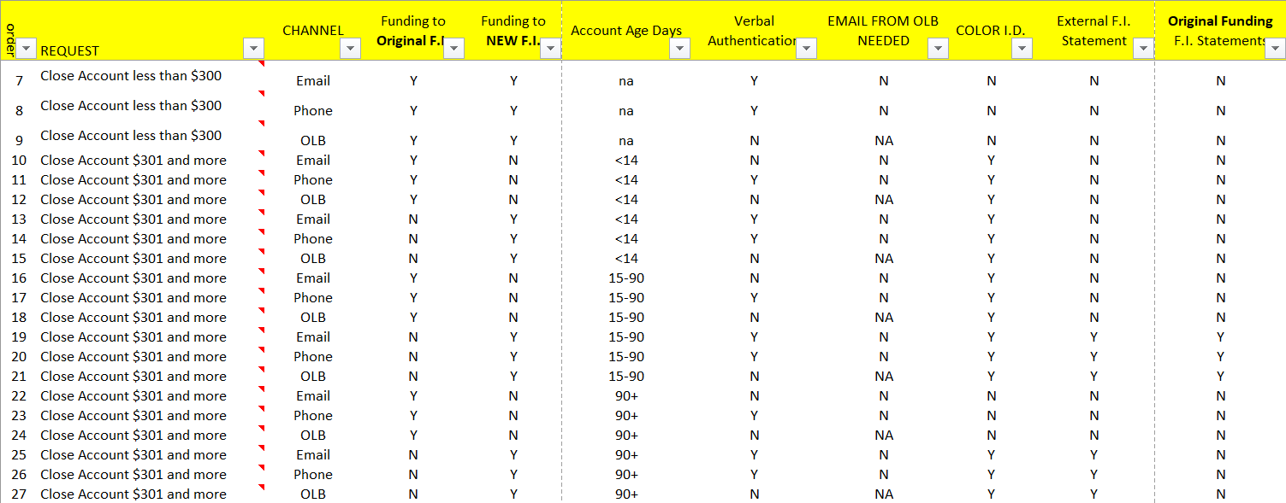
PROCEDURE:
ACCOUNT CLOSURE: CHECKING AND SAVINGS
STEP | EXPECTATION | IMAGE
 | Locate the client’s request through the following CX channels:  Email  - HubSpot  General Question Message  - FIS Web Admin  Inbound/Outbound phone call  - Must submit a written request through the channel above  - Send a confirmation response to your email | 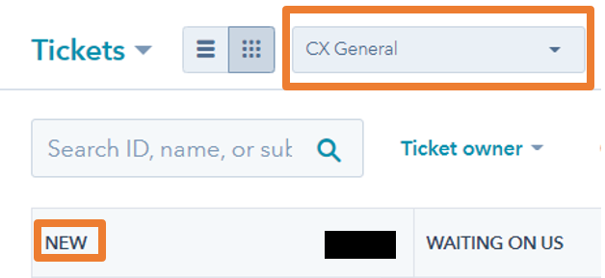  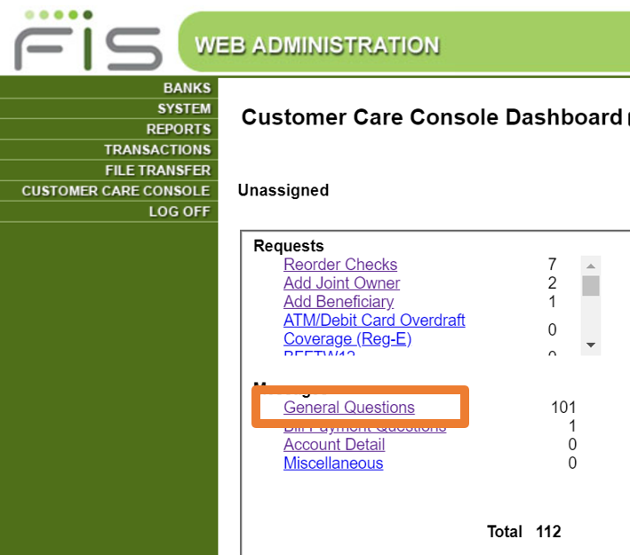
 | Locate the Client’s Account in Horizon XE
 | Quality Assurance (Q.A.):  Email: Verify that the email address matches the client’s contact profile on Horizon XE before completing their request  If the email does NOT match, direct the client to send a secure message through their online banking portal  OLB Secure Message: No need to verify since the client sent their request through their online banking portal  Phone Call: Verify the Client you have on the phone through Quontic’s verification process – verify four (4) aspects of the account to the right | 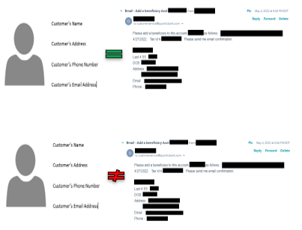  I.B. Phone Call Verification Questions:  - Client’s First and Last Name  - Client’s Account Number  - Client’s Address  - Client’s last four digits of social security number  - Client’s Date of Birth  - Client’s Username
 | Verify Account Status is Active. CX can proceed with the client’s request  If the account is Restricted, CX must address the restriction before moving forward with the request | 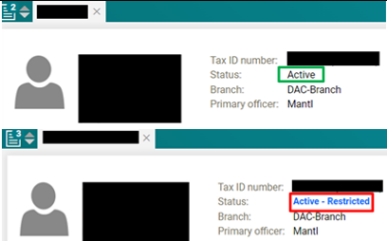
 | HubSpot  Click on Contacts  Search the Clients name  Click on the Client’s Name  If the client does have  Click on +Add next to Tickets  - Proceed to step #7  If the client does NOT  Proceed to step #6 | 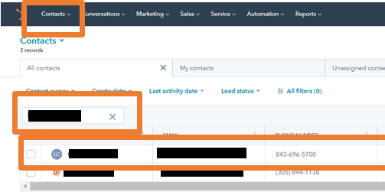
 | Click on Service  Click on Tickets  Click on Tribar  Change the Pipeline to All Pipelines  Search the Client’s Name or email address  If there is NO ticket with the same scenario, create a ticket  Click on Create Ticket on the right side of the page | 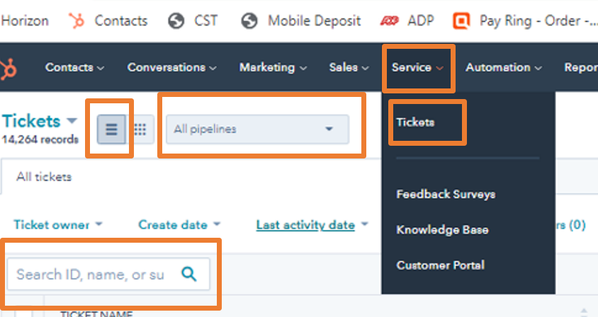  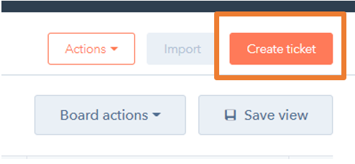
 | Email Ticket Name: Close [Account Type] [Last four digits of account] - [Client’s Name]  OLB Ticket Name: OLB – Close [Account Type] [Last four digits of account] - [Client’s Name]  I.B. Ticket Name: IB – Close [Account Type] [Last four digits of account] - [Client’s Name]  Pipeline: CX General or CX OLB Message  Ticket Status: OLB In Process or New  Ticket Description: Close Account  Product: OLB Checking/Savings  Ticket Owner: CX Representative  Source: Phone/ or Email/ or OLB Message  Create date: Today’s Date  Priority – High Priority  Click on Create | 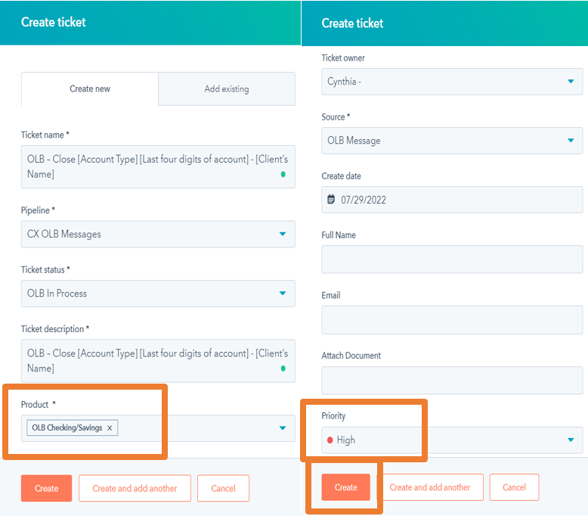
 | Pipeline: CX General or CX OLB Message  Ticket Status: OLB In Process or New  Ticket ID: Automatically Generated  Source: Phone/ or Email/ or OLB Message  Ticket Owner: CX Representative  Department- Quontic: Customer Success  Ticket Description: Close Account  Create date: Today’s Date  Change Priority to-  Medium Priority if we are missing documentation  High Priority if we are sending it to DBO  OLB Ticket Props:  Web Admin – OLB Original Submit Date – Date request submitted  Web Admin – OLB Reference Number – Reference Number  Banking Reason for Contact: Close Account Request  Refresh the page to see  Banking Reason for Contact:  - Asked/Would not provide  - Better Rate  - The wrong Acct Type Opened  - Not using account  - User Interface OLB/ App  - Did Not ask/ Unknown  - Poor Service  - Funds Needed  - Mortgage use only  - Rules Related  - External Transfer Limits  - External Transfer Rules  Click on one or multiple reasons closest to closure  Click on Save  Refresh the page to see  Product: OLB Checking/ Savings | 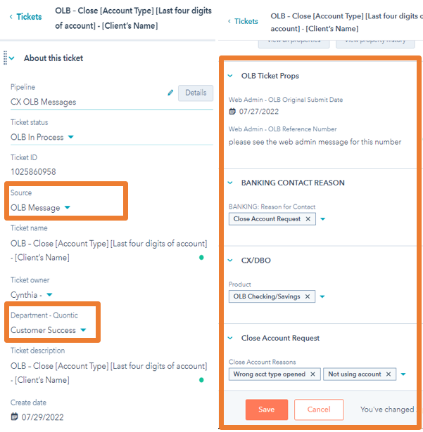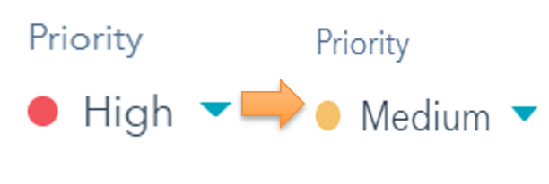
 | Horizon:  Click on Relationship Summary  Click on Customer Accounts  Verify  - Funds are available  - No Holds on the profile or account  Primary Office  - Mantl  - OAC  - Max Savings  - Astoria- branch  Click on the Activity Symbol next to the account in question  - Shortcut | 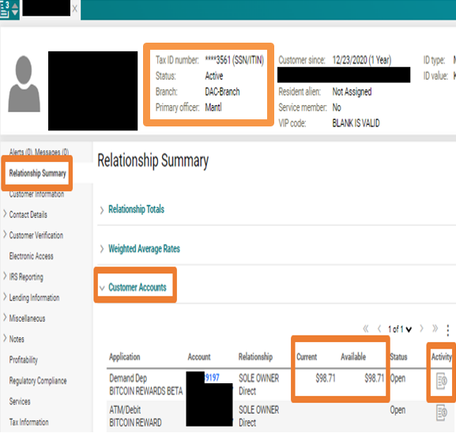
 | Click on the account in question  Click on History  Click on Transaction  The CX team can change the Statement Period from  - Last 10 transaction  - Last 10 days  - Last 30 days  - Last 60 days  - Date Range | 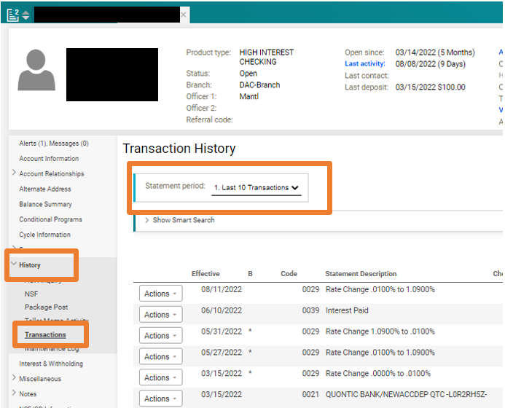
 | Verify there are no pending transactions on the History Page  Continue with request  - If there is a pending transaction on the account. Verify with the client that no more debit will be withdrawn | 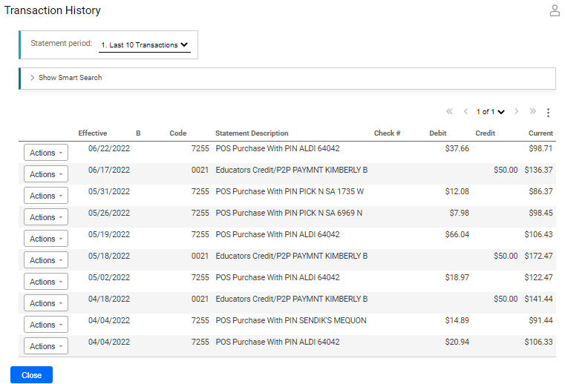
 | HubSpot:  Click on Notes  Click on Create Note  Include these snippets in your note with a short description  FIRST  Horizon XE Profile, OLB Messages  Snippet #1:  Client’s profile on Horizon XE  Snippet #2:  OLB Message to/ from the client  Click Print  Snippet #3:  Client’s Funding Account in Mantl  Snippet #4:  Insert the client’s I.D.s as part of the snippet or add it as an attachment on the HubSpot ticket  Click Save on your HubSpot note  See the example on the right | 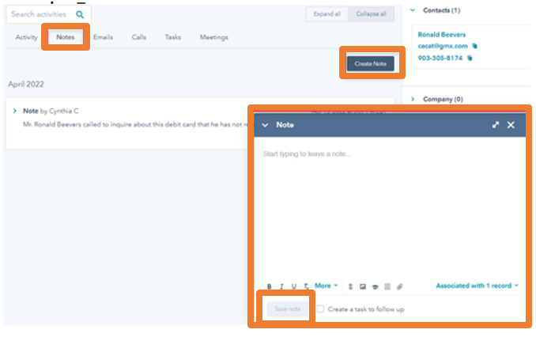  Horizon profile, OLB request  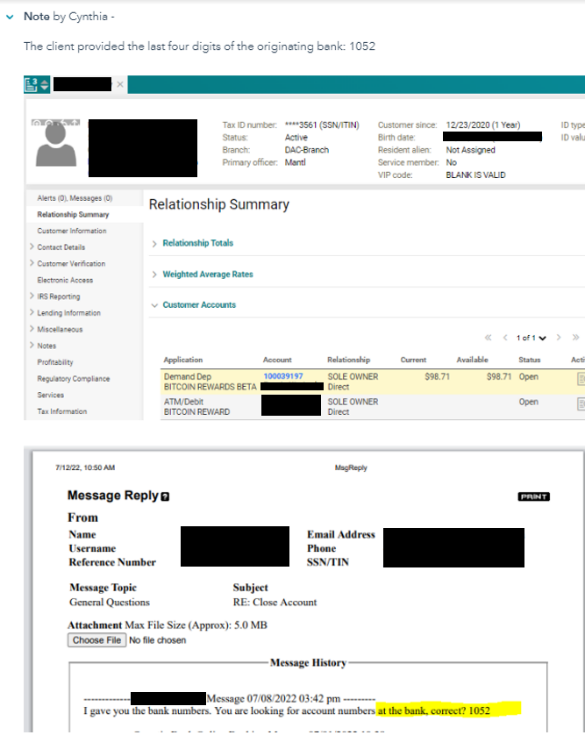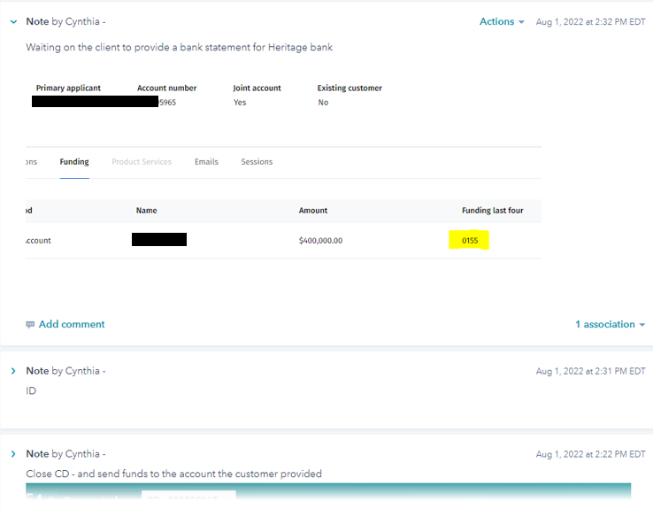
 | Change Ticket Status to OLB Waiting on Contact – Closed or Waiting on Contact – Closed depending on the pipeline | 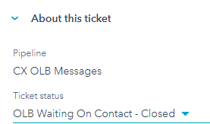
 | If the client has submitted all the information required for closure, send it to DBO  Change Pipeline to DBO – Close Account Requests  Ticket Status – New | 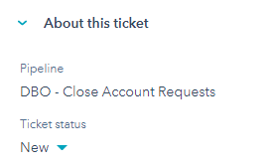
 | Once DBO says the account is closed  - Notify the client if DBO has not  See the Account Closure Confirmation email template  Change Pipeline to CX OLB Message/ CX General  - Verify the ticket to decide which pipeline it should go to  Change Ticket Status to OLB Closed-Resolved/ Closed-Resolved  - Verify the ticket to decide which pipeline it should go to | 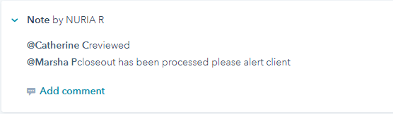  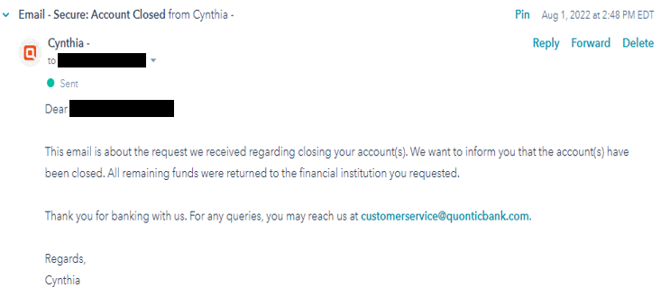

ACCOUNT CLOSURE: CERTIFICATE OF DEPOSIT (CD)
STEP | EXPECTATION | IMAGE
Locate the client’s request through the following CX channels:

Email
- HubSpot

General Question Message
- FIS Web Admin

Phone
- Must submit a written request through the channel above
- Send a confirmation response to your email

 | Locate the Client’s Account in Horizon XE
 | Quality Assurance (Q.A.):  Email: Verify that the email address matches the client’s contact profile on Horizon XE before completing their request  If the email does NOT match, direct the client to send a secure message through their online banking portal  OLB Secure Message: No need to verify since the client sent their request through their online banking portal  Phone Call: Verify the Client you have on the phone through Quontic’s verification process – verify four (4) aspects of the account to the right | I.B. Phone Call Verification Questions:  - Client’s First and Last Name  - Client’s Account Number  - Client’s Address  - Client’s last four digits of social security number  - Client’s Date of Birth  - Client’s Username
Verify Account Status is Active. CX can proceed with the client’s request

If the account is Restricted, CX must address the restriction before moving forward with the request
HubSpot

Click on Contacts

Search the Clients name

Click on the Client’s Name

If the client does have

Click on +Add next to Tickets
- Proceed to step #7

If the client does NOT
Proceed to step #6
Click on Service
Click on Tickets
Click on Tribar

Change the Pipeline to All Pipelines
Search the Client’s Name or email address

If there is NO ticket with the same scenario, create a ticket
Click on Create Ticket on the right side of the page
 | Email Ticket Name: Close [Account Type] [Last four digits of account] - [Client’s Name]  OLB Ticket Name: OLB – Close [Account Type] [Last four digits of account] - [Client’s Name]  I.B. Ticket Name: IB – Close [Account Type] [Last four digits of account] - [Client’s Name]  Pipeline: CX General or CX OLB Message  Ticket Status: OLB In Process or New  Ticket Description: Close Account  Product: C.D.s  Ticket Owner: CX Representative  Source: Phone/ or Email/ or OLB Message  Create date: Today’s Date  Priority – High Priority  Click on Create | 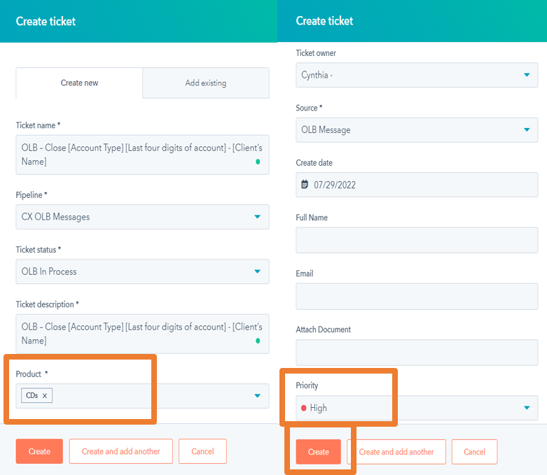
 | Pipeline: CX General or CX OLB Message  Ticket Status: OLB In Process or New  Ticket ID: Automatically Generated  Source: Phone/ or Email/ or OLB Message  Ticket Owner: CX Representative  Department- Quontic: Customer Success  Ticket Description: Close Account  Create date: Today’s Date  Change Priority to-  Medium Priority if we are missing documentation  High Priority if we are sending it to DBO  OLB Ticket Props:  Web Admin – OLB Original Submit Date – Date request submitted  Web Admin – OLB Reference Number – Reference Number  Banking Reason for Contact:  Close CD – In Retention Process  Close CD - Penalty Need Funds  Close CD – Transfer to Quontic Acct  Close CD – No Response to Retention  Close CD – Rate Issue  Close CD – Need Funds  Close CD – Customer Service Related  Close CD – Would not provide reason  Close CD - Change Mind/Wrong Acct  Close CD – Website/ Portal Lacking  Close CD – Grace Period Rqst  Click on one or multiple reasons closest to closure  CD Actual Amount  - Balance on the account  CD Range Amount  Click on Save  Refresh the page to see  Product: C.D.s | 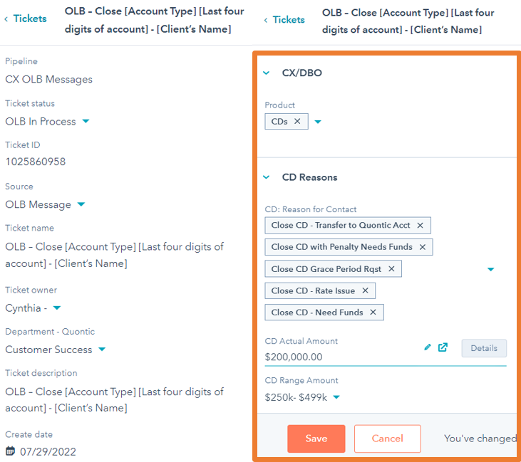
 | Horizon:  Click on Relationship Summary  Click on Customer Accounts  Verify  - Funds are available  - No Holds on the profile or account  Primary Office  - Mantl  - OAC  - Max Savings  - Astoria- branch  Early CD withdrawal  - Must receive penalty fee confirmation from the client  - Funds are available  - No Holds on the profile or account  Continue with request  Click on the client’s CD Account | 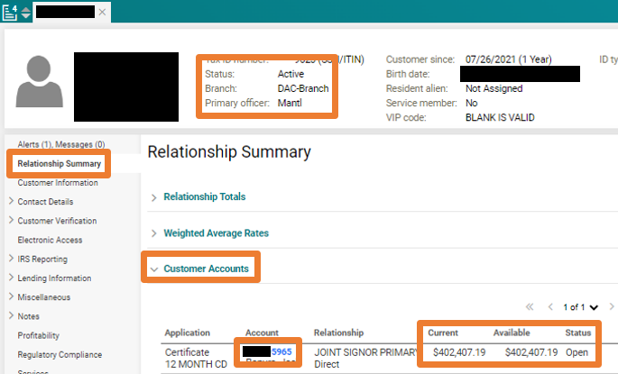
 | Status – Account in Grace Period  Click on Maturity Information  Last maturity date: When the CD matured  Continue with request | 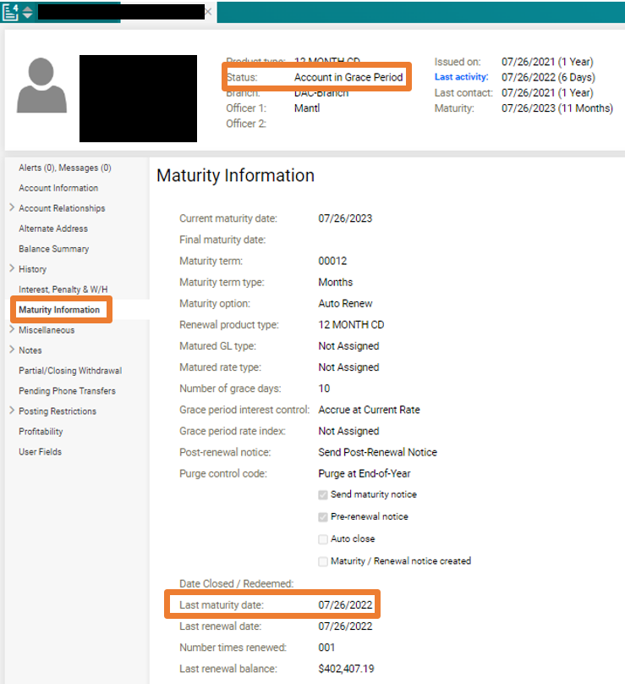
 | HubSpot:  Click on Notes  Click on Create Note  Include these snippets in your note with a short description  FIRST  Horizon XE Profile, OLB Messages  Snippet #1:  Client’s profile on Horizon XE  Snippet #2:  OLB Message to/ from the client  Click Print  Snippet #3:  Client’s Funding Account in Mantl  Snippet #4:  Insert the client’s I.D.s as part of the snippet or add it as an attachment on the HubSpot ticket  Click Save on your HubSpot note  See the example on the right | Horizon profile, OLB request  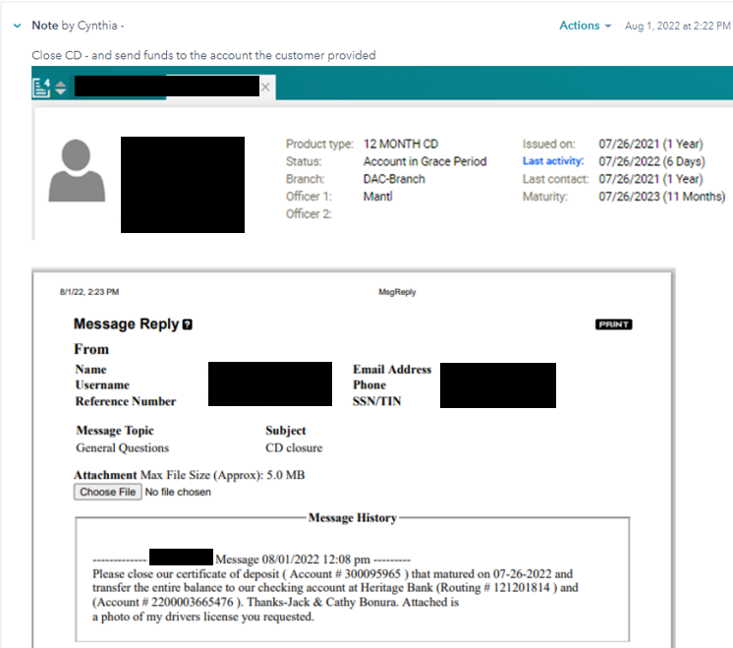  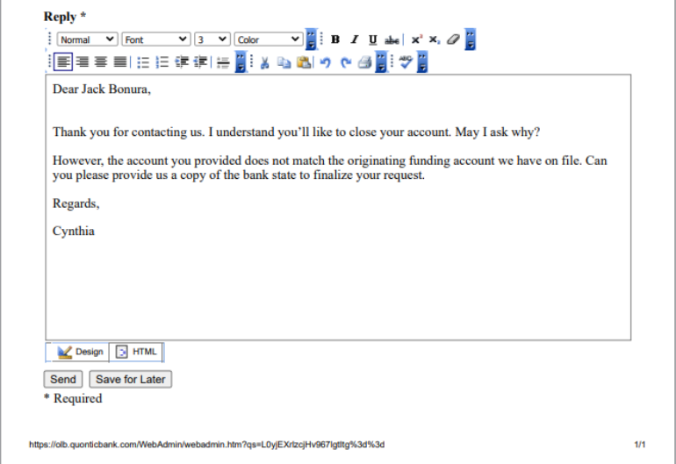
 | Change Ticket Status to OLB Waiting on Contact – Closed or Waiting on Contact – Closed depending on the pipeline
If the client has submitted all the information required for closure, send it to DBO

Change Pipeline to DBO – Close Account Requests

Ticket Status – New
Once DBO says the account is closed
- Notify the client if DBO has not
See the Account Closure Confirmation email template

Change Pipeline to CX OLB Message/ CX General
- Verify the ticket to decide which pipeline it should go to

Change Ticket Status to OLB Closed-Resolved/ Closed-Resolved
- Verify the ticket to decide which pipeline it should go to

ACCOUNT CLOSURE – ZERO BALANCE
STEP | EXPECTATION | IMAGE
Locate the client’s request through the following CX channels:

Email
- HubSpot
General Question Message
- FIS Web Admin
Phone
- Must submit a written request through the channel above
- Send a confirmation response to your email
 | Locate the Client’s Account in Horizon XE
 | Quality Assurance (Q.A.):  Email: Verify that the email address matches the client’s contact profile on Horizon XE before completing their request  If the email does NOT match, direct the client to send a secure message through their online banking portal  OLB Secure Message: No need to verify since the client sent their request through their online banking portal  Phone Call: Verify the Client you have on the phone through Quontic’s verification process – verify four (4) aspects of the account to the right | I.B. Phone Call Verification Questions:  - Client’s First and Last Name  - Client’s Account Number  - Client’s Address  - Client’s last four digits of social security number  - Client’s Date of Birth  - Client’s Username
Verify Account Status is Active. CX can proceed with the client’s request

If the account is Restricted, CX must address the restriction before moving forward with the request
HubSpot

Click on Contacts

Search the Clients name

Click on the Client’s Name

If the client does have

Click on +Add next to Tickets
- Proceed to step #7

If the client does NOT
Proceed to step #6
Click on Service
Click on Tickets

Click on Tribar

Change the Pipeline to All Pipelines

Search the Client’s Name or email address

If there is NO ticket with the same scenario, create a ticket

Click on Create Ticket on the right side of the page
 | Email Ticket Name: Close [Account Type] [Last four digits of account] – Zero Balance - [Client’s Name]  OLB Ticket Name: OLB – Close [Account Type] [Last four digits of account] – Zero Balance - [Client’s Name]  I.B. Ticket Name: IB – Close [Account Type] [Last four digits of account] – Zero Balance - [Client’s Name]  Pipeline: CX General or CX OLB Message  Ticket Status: OLB In Process or New  Ticket Description: Close Account  Product: OLB Checking/ Savings or C.D.s  Ticket Owner: CX Representative  Source: Phone/ or Email/ or OLB Message  Create date: Today’s Date  Priority – High Priority  Click on Create | 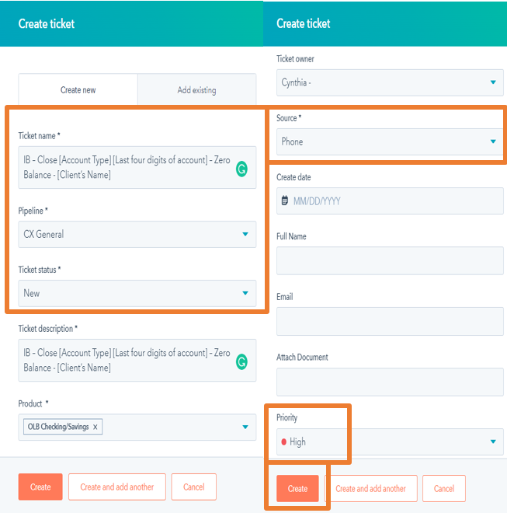
 | Pipeline: CX General or CX OLB Message  Ticket Status: OLB In Process or New  Ticket ID: Automatically Generated  Source: Phone/ or Email/ or OLB Message  Email Ticket Name: Close [Account Type] [Last four digits of account] – Zero Balance - [Client’s Name]  OLB Ticket Name: OLB – Close [Account Type] [Last four digits of account] – Zero Balance - [Client’s Name]  I.B. Ticket Name: IB – Close [Account Type] [Last four digits of account] – Zero Balance - [Client’s Name]  Ticket Owner: CX Representative  Department- Quontic: Customer Success  Ticket Description: Close Account  Create date: Today’s Date  Change Priority to-  Medium Priority if we are missing documentation  High Priority if we are sending it to DBO  OLB Ticket Props:  Web Admin – OLB Original Submit Date – Date request submitted  Web Admin – OLB Reference Number – Reference Number  Banking Reason for Contact:  Click on one or multiple reasons closest to closure  Click on Save  Refresh the page to see  Product: OLB Checking/ Savings or C.D.s | 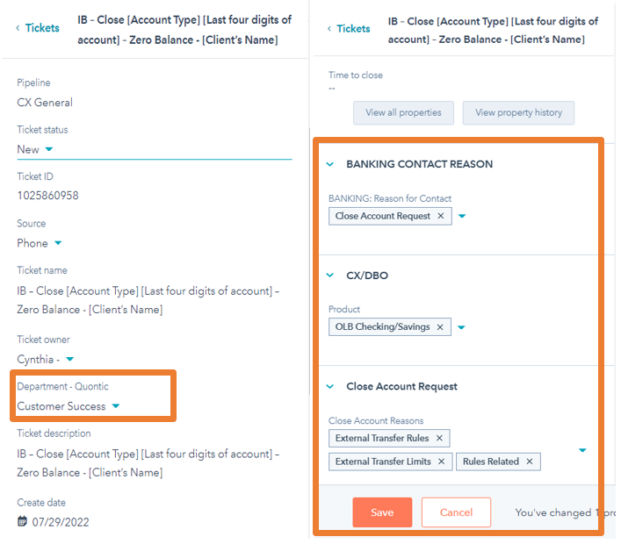
 | Horizon:  Click on Relationship Summary  Click on Customer Accounts  Verify  - Available balance = ZERO balance  Status  - Active  Primary Office  - Mantl  - OAC  - Max Savings  - Astoria- branch | 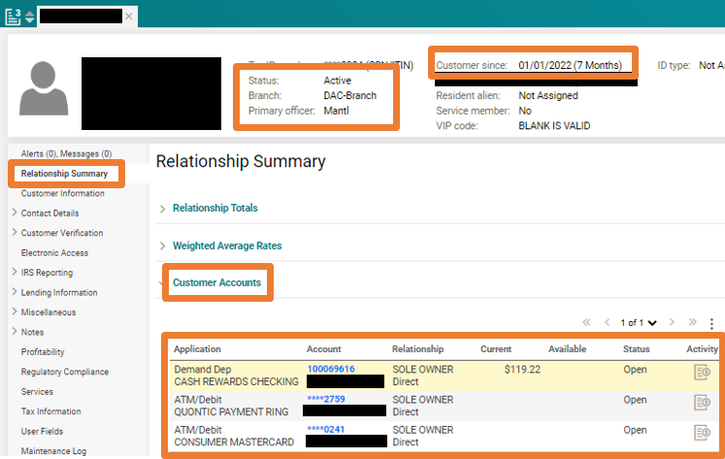
 | Click on Activity Symbol next to the account in question | 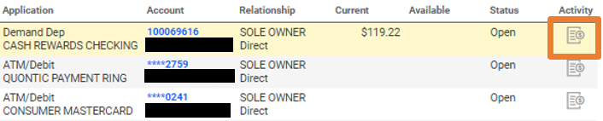
 | Verify the last transactions  Example: The client has transferred all the money out of the account, leaving the current balance at ZERO  Send the clients request to DBO to close the account | 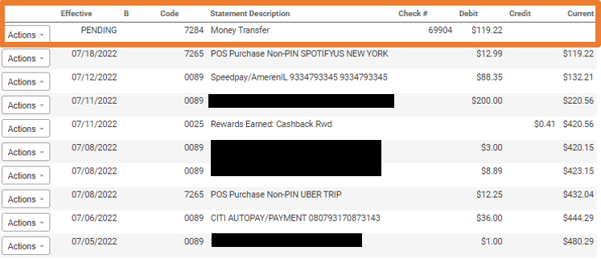
 | HubSpot:  Click on Notes  Click on Create Note  Include these snippets in your note with a short description  FIRST  Horizon XE Profile, OLB Messages  Snippet #1:  Client’s profile on Horizon XE  Snippet #2:  OLB Message to/ from the client  Click Print  Snippet #3:  Client’s Funding Account in Mantl  Snippet #4:  Insert the client’s I.D.s as part of the snippet or add it as an attachment on the HubSpot ticket  Click Save on your HubSpot note  See the example on the right | Horizon profile, OLB request  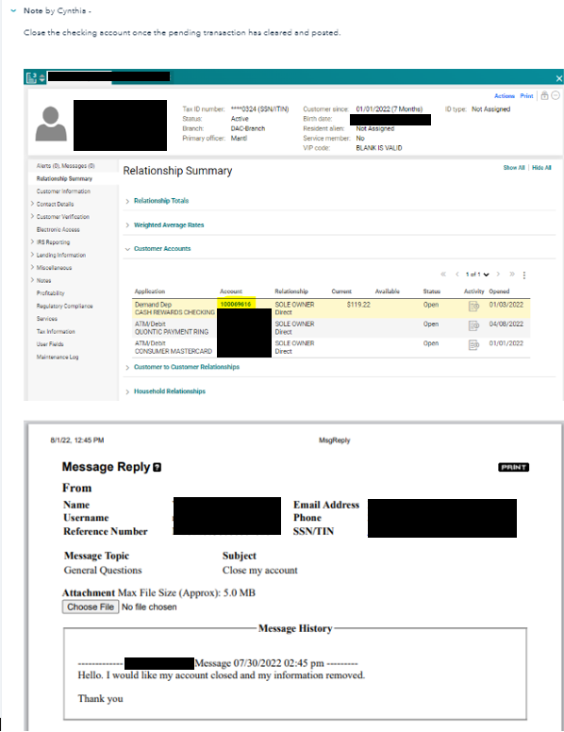
Change Pipeline to DBO – Close Account Requests

Ticket Status New

Refresh the page
 | Once DBO says the account is closed  - Notify the client if DBO has not  See the Account Closure Confirmation email template | 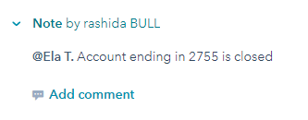  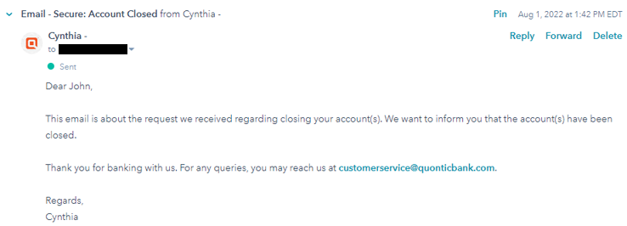
 | Change Pipeline to CX OLB Message/ CX General  - Verify the ticket to decide which pipeline it should go to  Change Ticket Status to OLB Closed-Resolved/ Closed-Resolved  - Verify the ticket to decide which pipeline it should go to | 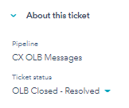

CHARGE-OFF ACCOUNT CLOSURE
STEP | EXPECTATION | IMAGE
 | Locate the client’s request through the following CX channels:  Email  - HubSpot  General Question Message  - FIS Web Admin  Phone  - Must submit a written request through the channel above  Send a confirmation response to your email | 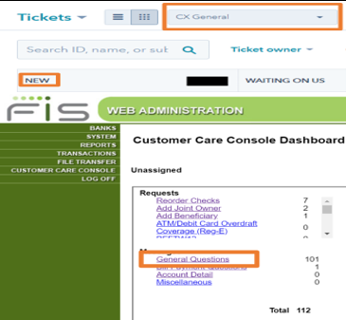
 | Locate the Client’s Account in Horizon XE
 | Quality Assurance (Q.A.):  Email: Verify that the email address matches the client’s contact profile on Horizon XE before completing their request  If the email does NOT match, direct the client to send a secure message through their online banking portal  OLB Secure Message: No need to verify since the client sent their request through their online banking portal  Phone Call: Verify the Client you have on the phone through Quontic’s verification process – verify four (4) aspects of the account to the right | I.B. Phone Call Verification Questions:  - Client’s First and Last Name  - Client’s Account Number  - Client’s Address  - Client’s last four digits of social security number  - Client’s Date of Birth  - Client’s Username
Verify Account Status is Active. CX can proceed with the client’s request

If the account is Restricted, CX must address the restriction before moving forward with the request
 | HubSpot  Click on Contacts  Search the Clients name  Click on the Client’s Name  If the client does have  Click on +Add next to Tickets  - Proceed to step #7  If the client does NOT  Proceed to step #6 | 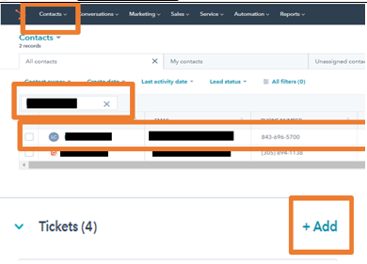
Click on Service
Click on Tickets

Click on Tribar

Change the Pipeline to All Pipelines

Search the Client’s Name or email address
If there is NO ticket with the same scenario, create a ticket
Click on Create Ticket on the right side of the page
 | Email Ticket Name: Charge-off Account [Last four digits of account] – [Client’s Name]  OLB Ticket Name: OLB – Charge-off Account [Last four digits of account] – [Client’s Name]  I.B. Ticket Name: I.B. – Charge-off Account [Last four digits of account] – [Client’s Name]  Pipeline: CX General or CX OLB Message  Ticket Status: OLB In Process or New  Ticket Description: Charge-off Account  Product: OLB Checking/ Savings  Ticket Owner: CX Representative  Source: Phone/ or Email/ or OLB Message  Create date: Today’s Date  Priority – High Priority  Click on Create | 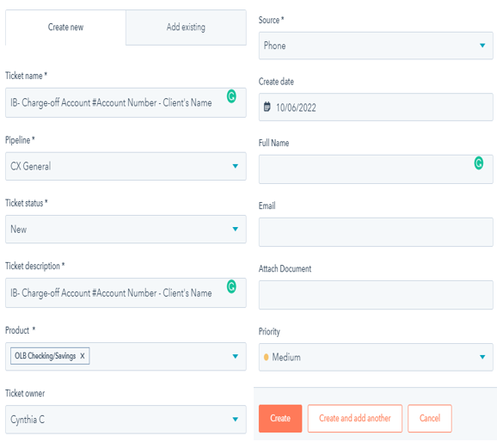
 | Pipeline: CX General or CX OLB Message  Ticket Status: OLB In Process or New  Ticket ID: Automatically Generated  Source: Phone/ or Email/ or OLB Message  Email Ticket Name: Charge-off Account [Last four digits of account] – [Client’s Name]  OLB Ticket Name: OLB – Charge-off Account [Last four digits of account] – [Client’s Name]  I.B. Ticket Name: I.B. – Charge-off Account [Last four digits of account] – [Client’s Name]  Ticket Owner: CX Representative  Department- Quontic: Customer Success  Ticket Description: Charge-off Account  Create date: Today’s Date  Change Priority to-  Medium Priority if we are waiting on the client  High Priority if we are sending it to DBO  OLB Ticket Props:  Web Admin – OLB Original Submit Date – Date request submitted  Web Admin – OLB Reference Number – Reference Number  Banking Reason for Contact:  Charge-off  Click on Save  Refresh the page to see  Product: OLB Checking/ Savings | 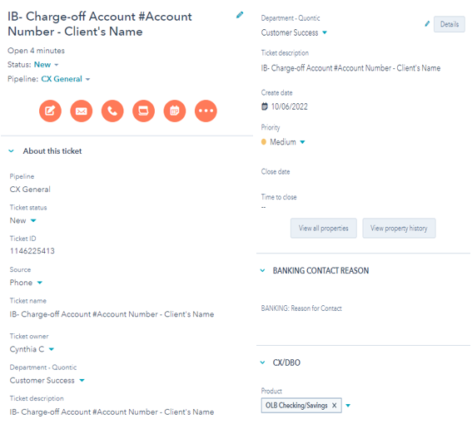
Horizon:

Click on Relationship Summary

Click on Customer Accounts

Verify
- Available balance = ZERO balance

Status
- Active

Primary Office
- Mantl
- OAC
- Max Savings
Astoria- branch
 | Horizon:  Click on Relationship Summary  Click on Customer Accounts  Click on History  Click on Transaction  Verify when the account was charged off and closed | 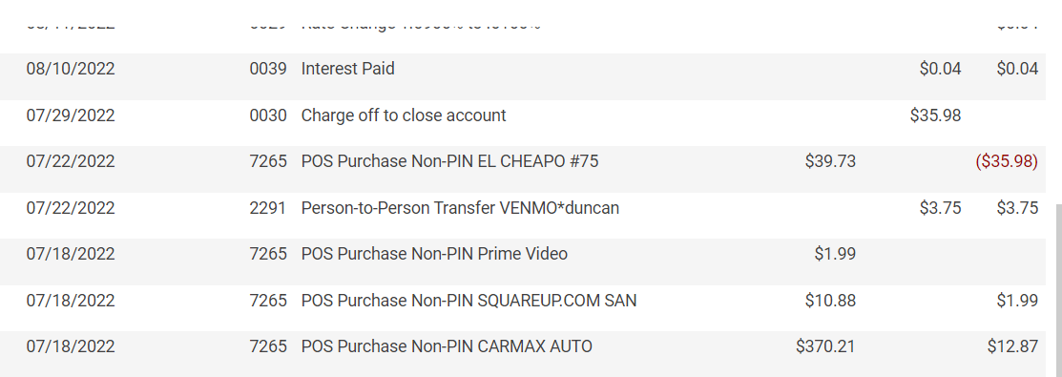
 | HubSpot:  Click on Notes  Click on Create Note  Include these snippets in your note with a short description  FIRST  Horizon XE Profile, OLB Messages  Snippet #1:  Client’s profile on Horizon XE  Snippet #2:  OLB Message to/ from the client  Click Print  See the example on the right  Click Save on your HubSpot note | Horizon profile, OLB request
 | Change Ticket Status to OLB Waiting on Contact – Closed or Waiting on Contact – Closed depending on the pipeline
 | If the client states they have initiated a transfer to off-set the negative balance  Change Pipeline to DBO – General  Ticket Status – New | 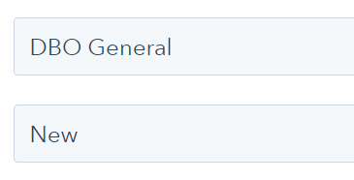
 | Once DBO has provided guidance or approval  - Notify the client of the decision made  See the Account Re-open Confirmation email template or Declined Re-opened email template | 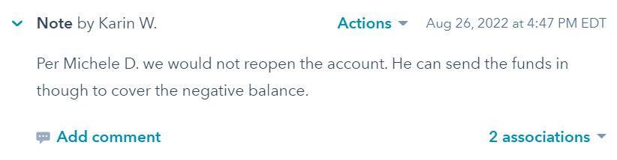
Change Pipeline to CX OLB Message/ CX General
- Verify the ticket to decide which pipeline it should go to

Change Ticket Status to OLB Closed-Resolved/ Closed-Resolved
Verify the ticket to decide which pipeline it should go to

EMAIL TEMPLATE:
Account Closure – I.B. Balance Confirmation Needed
Dear {{contact.first name }} {{contact.last name }},

Thank you for speaking to me today. I understand you would like to close your account. If you wish to continue to close out your account, please confirm to this email, and depending on how you would like your funds returned, we need some information from you:

Return funds to originating fund account:
- Please confirm the last four digits of the funding account
- Color copy of your valid government-issued I.D.

Return funds to a different account:
a. Color copy of your valid government-issued I.D.
b. copy of a bank statement (must have your name and account number)
c. Bank routing number

I look forward to further assisting you with your banking needs.

Thank you for being the best part of Quontic.

Best regards,
{{ticket.hubspot_owner_id }}​

Account Closure – I.B. Zero Balance Confirmation Needed
Dear {{contact.first name }} {{contact.last name }},

Thank you for speaking to me today. I understand you would like to close your account. Please confirm to this email if you wish to continue closing your account.

I look forward to further assisting you with your banking needs.

Thank you for being the best part of Quontic.

Best regards,
{{ticket.hubspot_owner_id }}​

Account Closure: Account less than 90 days/ more than $301+
Dear {{contact.first name }} {{contact.last name }},

Thank you for contacting us regarding your account. I understand you would like to close your account. May I ask why?

If you wish to continue to close out your account, depending on how you would like your funds returned, we need some information from you:

Return funds to originating fund account:
- Please confirm the last four digits of the funding account
- Color copy of your valid government-issued I.D.

Return funds to a different account:
a. Color copy of your valid government-issued I.D.
b. copy of a bank statement (must have your name and account number)
c. Bank routing number

(Note if using Online Banking Secure Messaging: Please use the “choose file” to upload your file. One file per message; you will have to send a secure message for each requested copy.)

I look forward to further assisting you with your banking needs.

Thank you for being the best part of Quontic.

Best regards,
{{ticket.hubspot_owner_id }}​

Account Closure: Account less than 90 days/ less than $300
Dear {{contact.first name }} {{contact.last name }},

Thank you for contacting us regarding your account. I understand you would like to close your account. May I ask why?

If you wish to continue to close out your account, depending on how you would like your funds returned, we need some information from you:

Return funds to originating fund account:
a. Please confirm the last four digits of the funding account

Return funds to a different account:
a. Color copy of your valid government-issued I.D.
b. copy of a bank statement (must have your name and account number)
c. Bank routing number

(Note if using Online Banking Secure Messaging: Please use the “choose file” to upload your file. One file per message; you will have to send a secure message for each requested copy.)

I look forward to further assisting you with your banking needs.

Thank you for being the best part of Quontic.

Best regards,
{{ticket.hubspot_owner_id }}​

Account Closure: Account over 90 days
Dear {{contact.first name }} {{contact.last name }},

Thank you for contacting us regarding your account. I understand you would like to close your account. May I ask why?

If you wish to continue to close out your account, depending on how you would like your funds returned, we need some information from you:

Return funds to originating fund account:
a. Please confirm the last four digits of the funding account

Return funds to a different account:
a. Color copy of your valid government-issued I.D.
b. copy of a bank statement (must have your name and account number)
c. Bank routing number

(Note if using Online Banking Secure Messaging: Please use the “choose file” to upload your file. One file per message; you will have to send a secure message for each requested copy.)

We hate to lose you as a customer but understand that things happen. Once we understand where the funds should go and have the requested information, we can close your account as requested.

Quontic Bank values your business, and I want to reassure you that you receive great products and services while banking with us.

I look forward to further assisting you with your banking needs.

Thank you for being the best part of Quontic.

Best regards,
{{ticket.hubspot_owner_id }}​

Account Closure – Zero Balance Request
Dear {{contact.first name }} {{contact.last name }},

Thank you for contacting us regarding your account. I understand you would like to close your account. May I ask why?

We hate to lose you as a customer but understand that things happen. You will receive an email confirmation once your request is completed.

Quontic Bank values your business, and I want to reassure you that you receive great products and services while banking with us.

Thank you for being the best part of Quontic.

Best regards,
{{ticket.hubspot_owner_id }}​

Account Closure – CD Close-out w/ Rates
Dear {{contact.first name }} {{contact.last name }},

Thank you for contacting us regarding your CD account. We would love to keep you as a customer. Please see our newest CD Rates:

INSERT RATE APY 6 Months
INSERT RATE APY 1 Year
INSERT RATE APY 2 Years
INSERT RATE APY 3 Years
INSERT RATE APY 5 Years

If you wish to continue to close out your account, depending on how you would like your funds returned, we need some information from you:

Return funds to originating fund account:
a. Please confirm the last four digits of the funding account

Return funds to a different account:
a. Color copy of your valid government-issued I.D.
b. copy of a bank statement (must have your name and account number)
c. Bank routing number
(Note if using Online Banking Secure Messaging: Please use the “choose file” to upload your file. One file per message; you will have to send a secure message for each requested copy.)

We hate to lose you as a customer but understand that things happen. Once we understand where the funds should go and have the requested information, we can close your account as requested.

Quontic Bank values your business, and I want to reassure you that you receive great products and services while banking with us.

I look forward to further assisting you with your banking needs.

Thank you for being the best part of Quontic.

Best regards,
{{ticket.hubspot_owner_id }}​

Account Closure: CD Early Close-out w/penalty
Dear {{contact.first name }} {{contact.last name }},

Thank you for contacting us regarding your CD account. We would love to keep you as a customer; please see our newest CD Rates:

INSERT RATE APY 6 Months
INSERT RATE APY 1 Year
INSERT RATE APY 2 Years
INSERT RATE APY 3 Years
INSERT RATE APY 5 Years

If you wish to continue closing your account, confirm you are willing to pay [Amount Inserted Here] an early withdrawal penalty fee. Depending on how you would like your funds returned, we need some information from you:

Return funds to originating fund account:
a. Please confirm the last four digits of the funding account

Return funds to a different account:
a. Color copy of your valid government-issued I.D.
b. copy of a bank statement (must have your name and account number)
c. Bank routing number
(Note if using Online Banking Secure Messaging: Please use the “choose file” to upload your file. One file per message; you will have to send a secure message for each requested copy.)

We hate to lose you as a customer but understand that things happen. Once we understand where the funds should go and have the requested information, we can close your account as requested.

Quontic Bank values your business, and I want to reassure you that you receive excellent products and services while banking with us.

I look forward to further assisting you with your banking needs.

Thank you for being the best part of Quontic.

Best regards,
{{ticket.hubspot_owner_id }}​

Account Closure – Originating Funding does not match
Dear {{contact.first name }} {{contact.last name }},

Thank you for contacting us. I understand you’ll like to close your account. May I ask why?

Moreover, the last four digits of the account you provided do not match the originating funding account we have on file. Can you provide us with a copy of the following documents to complete your request:

- Color Copy of your I.D.
- Copy of the bank statement

Regards,
{{ticket.hubspot_owner_id }}​

Account Closure – Dormant Status Account Closure
Dear {{contact.first name }} {{contact.last name }},

Thank you for contacting us regarding your account. Your account is currently dormant due to no financial activity for an extended period. To continue with your close-out request, please complete the attached form and return it to us with how you would like your funds returned.

These are the following options we have to return your funds:

Return funds to originating fund account:
a. Please confirm the last four digits of the funding account

Return funds to a different account:
a. Color copy of your valid government-issued I.D.
b. copy of a bank statement (must have your name and account number)
c. Bank routing number
(Note if using Online Banking Secure Messaging: Please use the “choose file” to upload your file. One file per message; you will have to send a secure message for each requested copy.)

We hate to lose you as a customer but understand that things happen. Once we understand where the funds should go and have the requested information, we can close your account as requested.

Quontic Bank values your business, and I want to reassure you that you receive excellent products and services while banking with us.

I look forward to further assisting you with your banking needs.

Thank you for being the best part of Quontic.

Best regards,
{{ticket.hubspot_owner_id }}​

Account Closure – Involuntary Account Closure Zero Balance
Dear {{contact.first name }} {{contact.last name }},

Thank you for contacting us regarding your account. Your account has been closed due to no financial activity for an extended period.

Quontic Bank values your business, and I want to reassure you that you receive excellent products and services while banking with us.

If you wish to continue banking with Quontic, use the link below to open a new account

https://www.quontic.com/banking/open-an-account/

For any queries, you may reach us at customerservice@quonticbank.com.

Thank you for being the best part of Quontic.

Best regards,
{{ ticket.hubspot_owner_id }}​

Account Closure – Duplicate Account Closure
Dear {{contact.first name }} {{contact.last name }},

Thank you for contacting us regarding your account. Quontic is unable to close an account once it’s in process. I apologize for the inconvenience. These are the following options available to you:

- Contact the originating funding institution to place a stop payment. You will need the following information
  - Quontic Bank
  - The amount of the initial deposit
- Contact the originating funding institution and ask them to do an R-11; this will recall the initial deposit to your account.

However, if your bank cannot assist you, there is a 5-business-day hold on the initial deposit for verification purposes. After the hold has been released, Quontic can close the account.

Depending on how you would like your funds returned, we need some information from you:

Return funds to originating fund account:
- Please confirm the last four digits of the funding account
- Color copy of your valid government-issued I.D.

Return funds to a different account:
- Color copy of your valid government-issued I.D.
- Copy of a bank statement (must have your name and account number)
- Bank routing number

(Note if using Online Banking Secure Messaging: Please use the “choose file” to upload your file. One file per message; you will have to send a secure message for each requested copy.)

We hate to lose you as a customer but understand that things happen. Once we understand where the funds should go and have the requested information, we can close your account as requested.

Quontic Bank values your business, and I want to reassure you that you receive excellent products and services while banking with us.

I look forward to further assisting you with your banking needs.

Thank you for being the best part of Quontic.

Best regards,
{{ticket.hubspot_owner_id }}​

Account Closure – Bitcoin Checking Account Closure
Dear {{contact.first name }} {{contact.last name }},

Thank you for contacting us regarding your account. I understand you would like to close your Bitcoin account. May I ask why?
Quontic will redeem your bitcoin rewards (if any) before we close your account. The bitcoin redemption process does take 2-3 business days. Once the credit is posted on your account, your close-out request will be processed.

If you wish to continue to close out your account, depending on how you would like your funds returned, we need some information from you:

Return funds to originating fund account:
- Please confirm the last four digits of the funding account

Return funds to a different account:
- Color copy of your valid government-issued I.D.
- copy of a bank statement (must have your name and account number)
- Bank routing number

(Note if using Online Banking Secure Messaging: Please use the “choose file” to upload your file. One file per message; you will have to send a secure message for each requested copy.)

I look forward to further assisting you with your banking needs.

Thank you for being the best part of Quontic.

Best regards,
{{ticket.hubspot_owner_id }}​

Account Closure – Charge-off Account Closure
Dear {{contact.first name }} {{contact.last name }},

Thank you for contacting us regarding your account.

Your Quontic Bank account was overdrawn for $Negative Balance on Insert Date Here. The account was closed after the tenth day of it being overdrawn.

You can send an ACH electronic transfer to your account by using one of the following options to off-set the balance:
- Wire transfer
- External Transfer

For any queries, you may reach us at customerservice@quonticbank.com.

Thank you for being the best part of Quontic.

Best regards,
{{ ticket.hubspot_owner_id }}​

Wrong CD Term Opened – Change of Term
Dear {{contact.first name }} {{contact.last name }},

Thank you for contacting us regarding your account. To change the term of your Certificate of Deposit in our system, we will need you to provide the term you originally wanted to open.

Once we receive this information, we will update your Certificate of Deposit.

Quontic Bank values your business, and we want to reassure you that you receive excellent products and services while banking with us.

For any queries, you may reach us at customerservice@quonticbank.com.

Thank you for being the best part of Quontic.

Best regards,
{{ ticket.hubspot_owner_id }}​

Account Closure – Account closure w/ balance Confirmation
Dear {{contact.first name }} {{contact.last name }},

This email is about your request regarding closing your account(s). We want to inform you that the account(s) have been closed. All remaining funds were returned to the financial institution you requested. The account was closed with a zero balance.

Thank you for banking with us. For any queries, you may reach us at customerservice@quonticbank.com.

Regards,
{{ticket.hubspot_owner_id }}​

Account Closure – Account closure Zero Balance Confirmation
Dear {{contact.first name }} {{contact.last name }},

This email is about your request regarding closing your account(s). We want to inform you that the account(s) have been closed.

Thank you for banking with us. For any queries, you may reach us at customerservice@quonticbank.com.

Regards,
{{ticket.hubspot_owner_id }}​

REPORTS:
HubSpot reports tracking clients’ close-out requests and reasons for leaving. It keeps track of issues that can be resolved in future projects.

CONTROLS:
The Quality Assurance program will randomly review all CX work HubSpot tickets regarding all close-out requests.

APPENDIX:

